**JUDAISM**

**The Meaning of Rosh Hashanah**

Rosh Hashanah is the Jewish New Year, marking the beginning of the High Holy Days and a time for reflection and renewal.

About Rosh Hashanah

The history and spiritual significance of Rosh Hashanah.

Rosh Hashanah is the Jewish New Year, a time for reflection, repentance, and renewal. It marks the beginning of the Jewish High Holy Days and the start of the Ten Days of Repentance, which culminate in Yom Kippur. Rosh Hashanah, which means "Head of the Year" in Hebrew, is celebrated on the 1st and 2nd of Tishrei, the first month of the Hebrew calendar. In 2024, Rosh Hashanah will begin on Friday evening, September 6, and end on Sunday evening, September 8. During this holiday, Jews gather for prayer, introspection, and the sounding of the shofar, a ram's horn, which symbolizes a call to repentance. It is a time for self-examination and a fresh start as individuals seek forgiveness and set intentions for the year ahead.

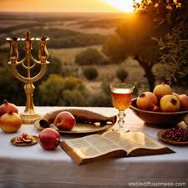

Rosh Hashanah Celebrations

A time for reflection, prayer, and renewal.

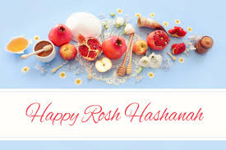

Rosh Hashanah is celebrated with festive meals, prayers, and special customs that mark the beginning of the Jewish New Year. On the first night, families come together for a festive meal that includes traditional foods such as apples dipped in honey, symbolizing the hope for a sweet new year. The shofar is blown during synagogue services to call upon the community to reflect and repent. The prayers during Rosh Hashanah include asking for forgiveness, making amends, and setting personal goals for the year ahead. A central theme of the holiday is "Teshuva" (return), which encourages individuals to repent for past mistakes and improve themselves spiritually. Rosh Hashanah is a time to deepen one's relationship with God and with others, as well as to seek blessings for the upcoming year.

Begin the Year with Reflection and Renewal

Rosh Hashanah offers a chance for spiritual growth, self-reflection, and making peace with the past. It is a time to seek forgiveness, set new intentions, and embrace the possibilities of the coming year. Let the blessings of Rosh Hashanah fill your heart with hope and renewal for a sweet and meaningful year ahead!